**OKC BHS MIS REPORTS**

|  |  |  |  |  |  |  |  |  |  |  |  |
| --- | --- | --- | --- | --- | --- | --- | --- | --- | --- | --- | --- |
| **Project Information:** | | | | | | | | | | | |
| Project Name: | | | Will Rogers World Airport (OKC) Checked Baggage Inspection System | | | | | | | | |
| Project Reference: | | | S32A1305700 | | | | | | | | |
| Document No: | | | OKC-DOC-1655-00-01 | | | | | | | | |
| Document Description: | | | Provide the statistical information gathering and report generation capability to display and print certain defined information considered essential to the successful operation of the system. | | | | | | | | |
| **Document Approval:** | | | | | | | | | | | |
| **Version** | **Date** |  | | **Author** | |  | **Reviewer** |  | **Approved By** | |  |
| 0.A | 7 Oct 2013 | Signature: | | Digitally  Reviewed | |  | Digitally  Reviewed |  | Digitally  Approved | |  |
| Name: | | Huang Ganzhou | |  | WX Ye |  | Freddy Lim | |  |
| **Document History:** | | | | | | | | | | | |
| **Version** | **Date** | **Author** | | | **Reviewer** | | **Reason** | | | **Approved By** | |
| 0.A | 28 Nov 2013 | Huang Ganzhou | | | WX Ye | | Initial Version | | | Freddy Lim | |
| 1.0 | 9 Jan 2014 | Guo Wenyu | | | EN Lee | | Review as commented | | | Freddy Lim | |
| 1.1 | 23 Jan 2014 | Guo Wenyu | | |  | |  | | |  | |
|  |  |  | | |  | |  | | |  | |
|  |  |  | | |  | |  | | |  | |
|  |  |  | | |  | |  | | |  | |
|  |  |  | | |  | |  | | |  | |
| **Distribution:** | | | | | | | | | | | |
| **Copy No** | **Version** | **Date** | | **Reason** | | | | | | | |
|  |  |  | |  | | | | | | | |

Contents

Contents 2

Table of Figure 4

1. Preface 5

1.1 Document Objective 5

1.2 Scope 5

1.3 Audience 5

1.4 Document Limitations 5

1.5 Document Maintenance 5

2. Abbreviations and Acronyms 6

3. Overview 7

3.1 Database Maintenance 7

4. Windows Form Based BHS Reporting 8

4.1 Report Selection Window 8

4.2 Report Preview Window 9

4.3 Report Preview Display Layout 13

5. BHS REPORT DESIGN AND SAMPLES 15

5.1 Throughput Report 15

5.2 Equipment Operational Summary Report 17

5.3 Equipment Malfunction and Correction Report 19

5.4 System Communications Behaviour 21

5.5 Flight Summary Report 23

5.6 BSM Tag Table Information 25

5.7 MES Utilization Report 27

5.8 Run-out Report 29

5.9 EDS Report 31

5.10 ATR Report 34

5.11 Day End Report 36

5.12 Sort Area Assignment Report 40

5.13 BSM Report 41

5.14 Computer and PLC Status Report 43

5.15 Individual PLC Status Report 45

5.16 Bags Data Reports 48

5.17 EDS Statistics Reports 50

5.18 Critical Tracking PEC Report 52

5.19 Tracking Photocell Report 54

5.20 Tracking Statistics Report 56

5.21 Baggage Measuring Statistics Report 58

5.22 OSR Statistics Report 60

5.23 CBRA Area statistics Report 62

5.24 Bag Tag Not Found Report 64

Table of Figure

Figure 4‑1: BHS Report Selection Window 8

Figure 4‑2: Report Preview Window 10

Figure 4‑3: Report Preview Window Toolbar 12

Figure 4‑4: Report in Print Window Toolbar 14

Figure 5‑1: Throughput Report Sample 16

Figure 5‑2: Equipment Operational Summary Report 18

Figure 5‑3: Equipment Malfunction and Correction Report 20

Figure 5‑4: System Communication Behaviour Report 22

Figure 5‑5: Flight Summary Report 24

Figure 5‑6: BSM Tag Table Information Report 26

Figure 5‑7: MES Utilization Report 28

Figure 5‑8: Run-out Report 30

Figure 5‑9: HBS Process Report 33

Figure 5‑10: ATR and BMA Report 35

Figure 5‑11: Day End Report 39

Figure 5‑12: Sort Area Assignment Report 40

Figure 5‑13: BSM Report 42

Figure 5‑14: Computer and PLC Status Report 44

Figure 5‑15: Individual PLC Status Report 47

Figure 5‑16: Bags Data Report 49

Figure 5‑17: EDS statistics Report 51

Figure 5‑18: Critical Tracking PEC Report 53

Figure 5‑19: Tracking Photocell Report 55

Figure 5‑20: Tracking Statistics Report 57

Figure 5‑21: Baggage Measuring Statistics Report 59

Figure 5‑22: OSR Statistics Report 61

Figure 5‑23: CBRA Area statistics Report 63

Figure 5‑21: Bag Tag Not Found Report Sample 65

# Preface

## Document Objective

The purpose of this document is to describe and specify the reports for Management Information System (MIS) of Will Rogers World Airport - Baggage Handling System (BHS).

The customer’s approval of the report design is required before the development of the reporting templates is started.

## Scope

The scope of this document includes all functionalities related to OKC BHS MIS REPORTS.

## Audience

This specification is intended for the customer’s decision maker, and the consultant of Will Rogers World Airport. This document will also serve as the primary foundation and reference for Pteris Global Limited (PGL) developers to implement the OKC BHS MIS REPORTS for the airport above.

## Document Limitations

This document is limited to the design of the OKC BHS MIS reporting system. There is no other external system description.

The document contains various reporting examples of OKC BHS MIS reporting components application. These examples are provided for assisting the perception of a given function or subsystem only. The actual system to be deployed for this site may have slight variation.

## Document Maintenance

This document is one of the PGL document management suites and it is maintained by PGL.

# Abbreviations and Acronyms

|  |  |
| --- | --- |
| **Terms and Abbreviations** | **Description** |
| ATR | Automatic Tag Reader |
| BDD | Baggage Dimension Device |
| BHS | Baggage Handling System |
| BIS | Baggage Identification System |
| BSI | Baggage System Interface. |
| BSM | Baggage Source Message. Refer to IATA RP 1745 |
| EDS | Explosives Detection System |
| FIS | Flight Information System. |
| HBS | Hold Bag Screening |
| IP | Internet Protocol - Communication Protocol |
| LAN | Local Area Network |
| MDS | Monitoring & Diagnostic System |
| MES | Manual Encoding System |
| MIS | Management Information System |
| OKC | OKLAHOMA CITY  WILL ROGERS WORLD AIRPORT |
| PGL | Pteris Global Limited |
| PLC | Programmable Logic Controller |
| TCP/IP | Communication Protocol |

# Overview

The BHS Reporting Application is PGL standard module for generating and printing of BHS reports. It can be accessed from the DA application which is running on SAC Operation Workstation.

The BHS Reporting solution is built on the Microsoft SQL Database Server 2012 Standard Edition and Microsoft SQL Server Reporting Service platform. They are installed on the Database server to provide the standalone or clustering database and reporting server for BHS.

The BHS report templates are designed for printing to A4 size paper. There will be a report printer which has built-in network interface to allow network printing via BHS LAN from SAC Operation Workstation.

## Database Maintenance

Up to 1 year of BHS historical data will be configured to store on the database server for reporting purpose. The historical data older than 1 year will be purged automatically by background database housekeeping schedule task.

# Windows Form Based BHS Reporting

The GUI design of Windows form based BHS report application is described in this chapter. The detailed design of the full set of BHS reports is described in Chapter 5 - BHS REPORT DESIGN AND SAMPLES.

## Report Selection Window

The report selection window is launched through a ***“BHS Report”*** button located on the menu bar of the main window of the BHS HLC workstation (SAC-OWS and MDS-OWS) application.

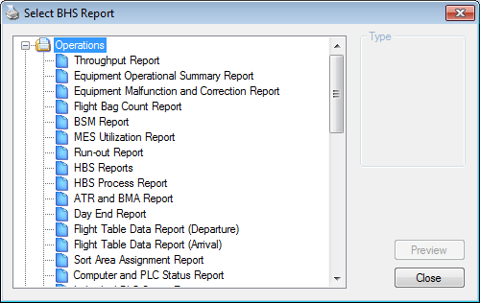

Figure 4‑1: BHS Report Selection Window

The report lists shown on Figure 4‑1 are for example. The actual delivery of the content will be deployed according to Will Rogers World Airport BHS report requirement.

The various areas on the Report Selection Window are described in table below.

| **Item** | **Name** | **Purpose/Function** |
| --- | --- | --- |
| **1** | Report List | Provide a list of available reports for the users to select and generate. All reports in the list can be generated from the workstation, MDSOWS and SACOWS. |
|
| **2** | Report Type Option | Some reports are categorized into details and summary.  Users can select either 1) Details or 2) Summary |
| **3** | Preview Button | Allow users to generate the selected report with the chosen report type (if available). This button will be enable if a report is selected in the Report List and disable when no report is selected in the Report List. |
|
| **4** | Close Button | Close the Report Selection Window. All opened Report Viewer will also be closed. |

## Report Preview Window

When a report is selected and generated, the following report preview window will pop up.

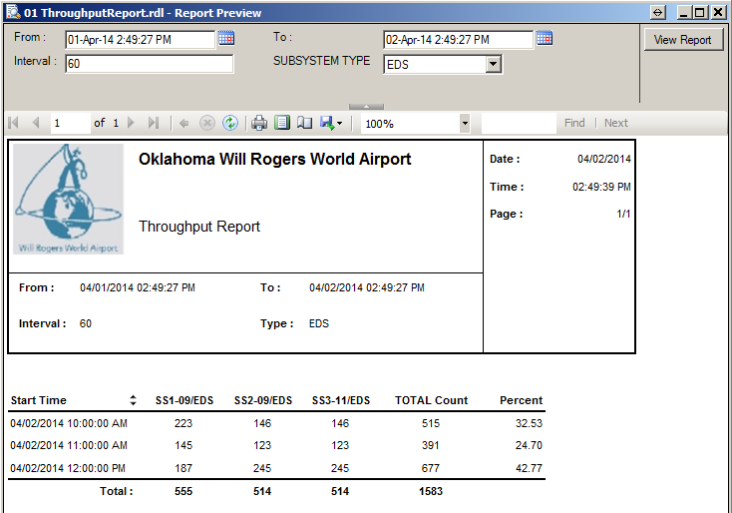

Figure 4‑2: Report Preview Window

The designed areas on the Report Preview Window are as described in the table below.

|  |  |  |
| --- | --- | --- |
| **Item** | **Name** | **Purpose/Function** |
| **1** | Title bar | (1) Indicates the name of the current report opened in the Report Viewer.  (2) Allows the users to drag the Report Viewer to different location around and within the screen.  (3) Allow the users to close the Report Viewer by clicking on the **X** button. |
| **2** | Parameter Entry Area | Allow users to specify and change all the required parameters before generating the report with the desired parameters. |
|
|
| **3** | Toolbar | Contains all the function buttons to perform specific function either on the generated report or on the Report Viewer environment. |
| **4** | Content Area | It displays the generated reports content and report information. |

The report parameters can be changed and the new result of report can be updated within the Preview window.

The Report Viewer will open with the selected report generated in the report content area if all the parameters for that report are supplied (refer to **Figure 4‑2** above). It varies from report to report, some reports are supplied with default value for all parameters and some are not.

The functions for the reports and Report Viewer environment are all hosted as respective function button hosted on the toolbar of the Report Viewer as shown in the figure below.



Figure 4‑3: Report Preview Window Toolbar

The function buttons and their associated function(s) are as described in table below.

| **Item** | **Name** | **Purpose/Function** |
| --- | --- | --- |
|  | Show/Hide Document Map Button | Allow users to show or hide the document map of the report. This function button is a toggle button. It is disabled at all time as it will not be used in this Report application. |
|  | Show/Hide Parameter Area Button | Allow users to show or hide the parameter area. |
|  | Navigation Bar | Allow users to navigate through the report pages for those reports that have more than one page. |
|  | Back to Parent Report Button | Allow users to return to its parent report from the drilled in report. This button will be disabled at all time as there is no drill in reports in this report application. |
|  | Stop Rendering Button | Allow users to stop (cancel) the rendering of a report. |
|  | Refresh Button | Allow users to refresh the report. |
|  | Print Button | Allow users to pop up the standard print dialogue box for selecting printer and configuring the printing settings for the report. |
|  | Print Layout Button | Allow users to switch between normal view and print layout view. This function button is a toggle button. |
|  | Page Setup Button | Allow users to setup the page for the report. |
|  | Export Button | Allow users to export the report in the following available file format:  •         Acrobat (PDF) file  •         Word  •         Excel |
|  | Zoom Selection Dropdown List | Allow users to zoom in or zoom out the entire report. Available options are:  •         Page Width  •         Whole Page  •         500%  •         200%  •         150%  •         100%  •         75%  •         50%  •         25% |
|  | Search Bar | Allow the users to search by specified the word entered in the text box of the search Bar. |

## Report Preview Display Layout

The Report Preview window provides two different layouts for viewing the report, namely the Normal view, and the Print Layout view.

The report will always be displayed in the normal view whenever it is selected and then generated via the Preview button on the Report Selection Window. The generated report can then be switched between the Normal View and the Print Layout View by clicking on the Print Layout toggle button ().

In the **Figure 4‑2** above, it is a generated report viewed in the Normal view, whereas the **Figure 4‑4** below shows the generated report viewed in Print Layout View.

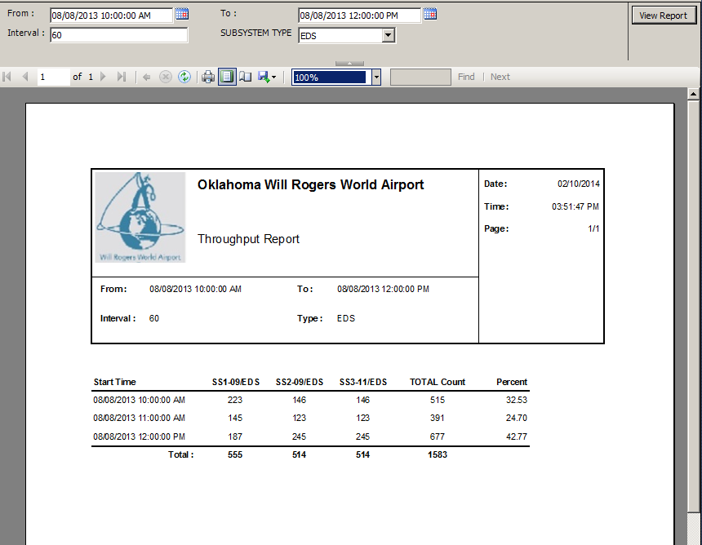

Figure 4‑4: Report in Print Window Toolbar

# BHS REPORT DESIGN AND SAMPLES

## Throughput Report

**General Information:**

|  |  |
| --- | --- |
| **Report Title** | Throughput Report |
| **Purpose** | Provides total number of bag inducted from each load point. This report is further broken into two categories –Those bags input without encoding and those bags manually encoded. |

**Report Boundaries:**

|  |  |  |
| --- | --- | --- |
| **No.** | **Parameter Name** | **Description** |
| 1 | From | The duration from which the data will be retrieved for the report. |
| 2 | To | The duration to which the data will be retrieved for the report. |
| 3 | Interval | The distribution interval in term of minutes to be used.  Selectable in 0 to 60 minute intervals. |
| 4 | Subsystem Type | The subsystem type used to filter report result.   1. Ticket Counters 2. All input conveyors 3. Manual encoding stations (MES) 4. Mainlines in the sort matrix (Mainline) 5. EDS devices in the EDS matrix (EDS) 6. Mainline Input 7. Make-up Devices (MU) 8. Run-out |

**Report Fields:**

|  |  |  |  |
| --- | --- | --- | --- |
| **No.** | **Fields Name** | **Data Type** | **Description** |
| 1 | Start Time | Date Time | The start time of each interval. |
| 2 | Device Name | Text | The devices belonging to selected subsystem type are shown in column title. |
| 3 | Total Count | Numeric | The total count of bags for each interval |
| 4 | Percent (%) | Numeric | The percentage of bags count in each interval out of overall total number of bags. |

**Report Sample:**

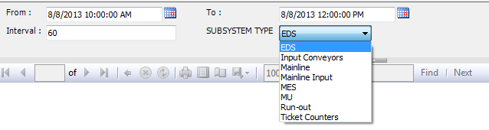

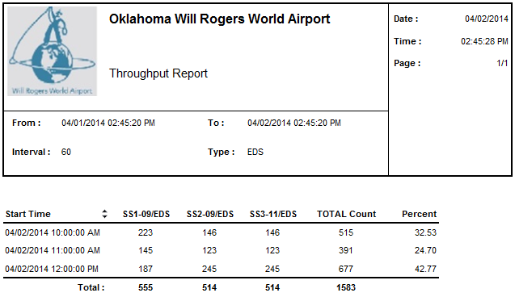

Figure 5‑1: Throughput Report Sample

## Equipment Operational Summary Report

**General Information:**

|  |  |
| --- | --- |
| **Report Title** | Equipment Operational Summary Report |
| **Purpose** | Provides summary of each equipment malfunction and correction. |

**Report Boundaries:**

|  |  |  |
| --- | --- | --- |
| **No.** | **Parameter Name** | **Description** |
| 1 | From | The duration from which the data will be retrieved for the report. |
| 2 | To | The duration to which the data will be retrieved for the report. |
| 3 | Subsystem | The subsystem(s) to be included in the report. This parameter can have multiple values. |

**Report Fields:**

|  |  |  |  |
| --- | --- | --- | --- |
| **No.** | **Fields Name** | **Data Type** | **Description** |
| **1** | **Tracking** | **-** | **-** |
| 1.1 | Photocell ID | Text | The identification of the Photocell . |
| 1.2 | Missing Bags | Numeric | The count of bags missing at photocell. |
| 1.3 | Unknown Bags | Numeric | The count of unknown bags at photocell. |
| 1.4 | JAMS | Numeric | The count of bag jams at photocell. |
| **2** | **JAMs** | **-** | **-** |
| 2.1 | Photocell ID | Text | The identification of the Photocell where bag jams happen. |
| 2.2 | JAMS | Numeric | The count of Jams. |
| **3** | **HSPD** | **-** | **-** |
| 3.1 | Equip. ID | Text | The identification of HSPD |
| 3.2 | Cycles | Numeric | The cycles of HSPD running |
| 3.3 | Jams | Numeric | The count of bag jams at HSPD. |
| 3.4 | Failed Position | Text | The latest position where malfunctions happen |
| 3.5 | E-stop | Numeric | The count of e-stop happening |

**Report Sample:**

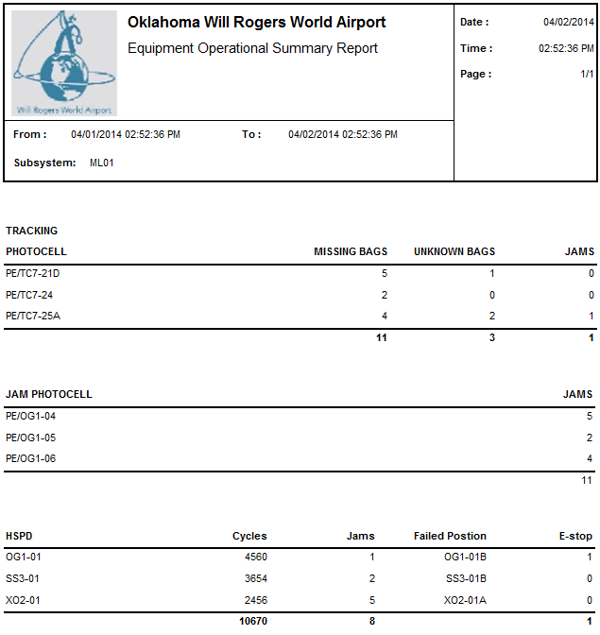

Figure 5‑2: Equipment Operational Summary Report

## Equipment Malfunction and Correction Report

**General Information:**

|  |  |
| --- | --- |
| **Report Title** | Equipment Malfunction and Correction Report |
| **Purpose** | Provides details of each equipment malfunction and correction. |

**Report Boundaries:**

|  |  |  |
| --- | --- | --- |
| **No.** | **Parameter Name** | **Description** |
| 1 | From | The duration from which the data will be retrieved for the report. |
| 2 | To | The duration to which the data will be retrieved for the report. |
| 3 | Subsystem | The subsystem(s) to be included in the report. This parameter can have multiple values. |
| 4 | Equipment ID | The equipment(s) to be included in the report. This parameter can have multiple values. |
| 5 | Fault Type | The fault type(s) to be included in the report. This parameter can have multiple values. |

**Report Fields:**

|  |  |  |  |
| --- | --- | --- | --- |
| **No.** | **Fields Name** | **Data Type** | **Description** |
| 1 | Subsystem | Text | The subsystem for which the equipment(s) belong to. |
| 2 | Equip. ID | Text | The identification of the equipment. |
| 3 | Start Time | Text | The start time of the fault occurrence. |
| 4 | End Time | Text | The end time of the fault occurrence. If the fault is still not recovered, this field will be empty. |
| 5 | Duration | Text | The duration of the fault occurrence specified in hh:mm:ss format. If the fault is still not recovered, this field will be empty.  *Note: HH = hours (24 hours format), mm = minutes, ss = seconds* |
| 6 | Description | Text | The description of the fault. |
| 7 | Count | Numeric | The total count of fault occurrence. |

**Report Sample:**

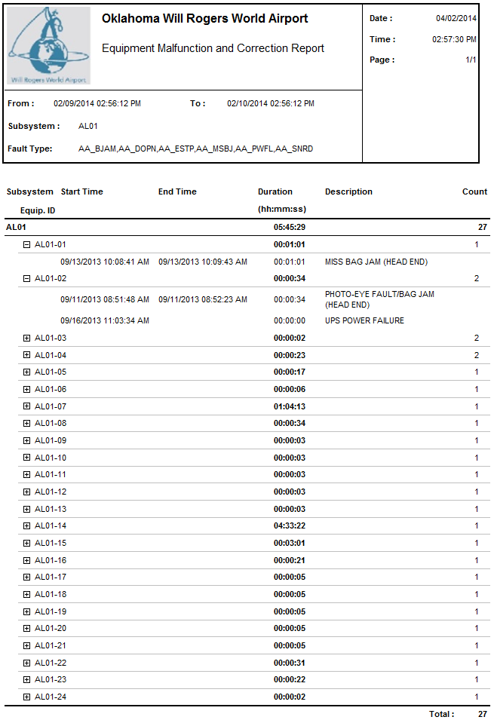

Figure 5‑3: Equipment Malfunction and Correction Report

## System Communications Behaviour

**General Information:**

|  |  |
| --- | --- |
| **Report Title** | System Communications Behavior Report |
| **Purpose** | Provides the information of faults status for the network. |

**Report Boundaries:**

|  |  |  |
| --- | --- | --- |
| **No.** | **Parameter Name** | **Description** |
| 1 | From | The duration from which the data will be retrieved for the report. |
| 2 | To | The duration to which the data will be retrieved for the report. |

**Report Fields:**

|  |  |  |  |
| --- | --- | --- | --- |
| **No.** | **Fields Name** | **Data Type** | **Description** |
| 1 | Equip. ID | Text | The network equipment name. |
| 2 | Start Time | Text | The start time of the fault occurred in network equipment. |
| 3 | End Time | Text | The end time of the fault occurred in network equipment. If the fault is still not recovered, this field will be empty. |
| 4 | Duration (HH:mm:ss) | Text | The duration of the fault occurrence network equipment specified in HH:mm:ss format. If the fault is still not recovered, this field will be empty.  *Note: HH = hours (24 hours format), mm = minutes, ss = seconds* |
| 5 | Description | Text | The description of the fault. |
| 6 | Count | Numeric | The total fault counts of each network equipment. |

**Report Sample:**

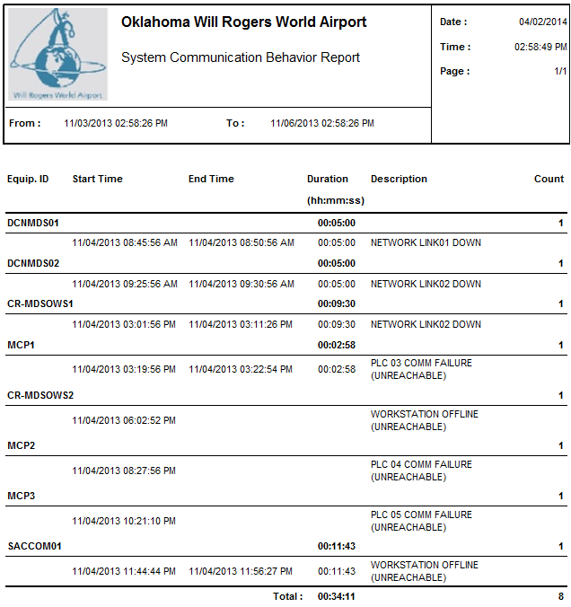

Figure 5‑4: System Communication Behaviour Report

## Flight Summary Report

**General Information:**

|  |  |
| --- | --- |
| **Report Title** | Flight Bag Count Report |
| **Purpose** | Provides notified bag count, bags seen count, bags not seen count, early bag count, regular bag count, late bag count, bag count per make-up. |

**Report Boundaries:**

|  |  |  |
| --- | --- | --- |
| **No.** | **Parameter Name** | **Description** |
| 1 | From | The duration from which the data will be retrieved for the report. |
| 2 | To | The duration to which the data will be retrieved for the report. |
| 3 | Airline | The Airline to be included in the report. This parameter can have multiple values. |
| 4 | Flight Number | The Flight Number to be included in the report. This parameter can have multiple values. |

**Report Fields:**

|  |  |  |  |
| --- | --- | --- | --- |
| **No.** | **Fields Name** | **Data Type** | **Description** |
| 1 | Airline | Text | The airline for which the flight belong to. |
| 2 | Flight | Text | The flight number of the data. |
| 3 | Bag Count | Numeric | The total count of bags belonging to the flight. |
| 4 | Bag Type | Numeric | The bag type.  O= Origination, X=Transfer, T=Terminating. |
| 5 | Bags On Time | Numeric | The count of bags sorted on time |
| 6 | Bags Late | Numeric | The count of bag sorted late |

**Report Sample:**

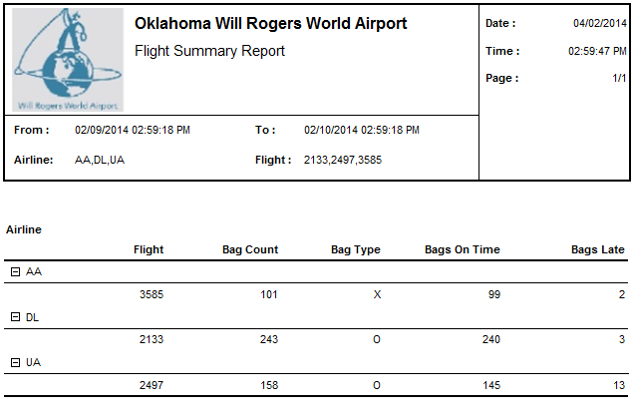

Figure 5‑5: Flight Summary Report

## BSM Tag Table Information

**General Information:**

|  |  |
| --- | --- |
| **Report Title** | BSM Tag Table Information Report |
| **Purpose** | Provides all received BSM details. |

**Report Boundaries:**

|  |  |  |
| --- | --- | --- |
| **No.** | **Parameter Name** | **Description** |
| 1 | SDO | The flight schedule departure date. |

**Report Fields:**

|  |  |  |  |
| --- | --- | --- | --- |
| **No.** | **Fields Name** | **Data Type** | **Description** |
| 1 | Tag ID | Text | The Tag ID of the baggage. |
| 2 | Name | Text | The passenger name. |
| 3 | Airline | Text | The airline for which the baggage belongs to. |
| 4 | Flight | Text | The flight number of the baggage belongs to. |
| 5 | STD | Text | The scheduled time of departure. |
| 6 | Read Time | Text | When ATR read the tag. |
| 7 | Read Location | Text | Where ATR read the tag. |
| 8 | Bag Type | Text | Passenger bag type. |
| 9 | MU | Text | The Make-up device that the bag assigned to. |
| 10 | Sorted | Text | The Make-up device that the bag sorted to. |

**\*Please note that only baggage which has BSM in BHS system will be shown in this report.**

**Report Sample:**

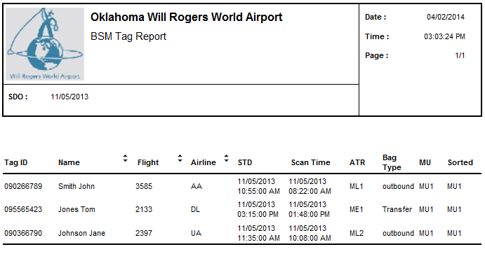

Figure 5‑6: BSM Tag Table Information Report

## MES Utilization Report

**General Information:**

|  |  |
| --- | --- |
| **Report Title** | MES Utilization Report |
| **Purpose** | Provides number of bags encoded per MES, type of bag encoded (No Read, No BSM, multiple BSM, multiple tags, no sort destination), bags encoded per subsystem for a specified number of minutes and total. |

**Report Boundaries:**

|  |  |  |
| --- | --- | --- |
| **No.** | **Parameter Name** | **Description** |
| 1 | From | The duration from which the data will be retrieved for the report. |
| 2 | To | The duration to which the data will be retrieved for the report. |

**Report Fields:**

|  |  |  |  |
| --- | --- | --- | --- |
| **No.** | **Fields Name** | **Data Type** | **Description** |
| **1** | **Reason To MES** |  |  |
| 1.1 | Unknown | Numeric | The count of redirected bags to MES by Unknown Reason |
| 1.2 | No Read | Numeric | The count of redirected bags to MES because tag is not read by ATR |
| 1.3 | Multiple Tag | Numeric | The count of redirected bags to MES by Multiple Tag |
| 1.4 | Multiple BSM | Numeric | The count of redirected bags to MES by Multiple BSM |
| 1.5 | Unknown Flight | Numeric | The count of redirected bags to MES by unknown flight |
| 1.6 | Unknown License Plate | Numeric | The count of redirected bags to MES by unknown license plate |
| 1.7 | No Allocation | Numeric | The count of redirected bags to MES by No Allocation |
| 1.8 | Problem Bag | Numeric | The count of redirected bags to MES by Problem Bag |
| **2** | **Dispatched By** |  |  |
| 2.1 | License Plate | Numeric | The count of dispatched bags by License Plate. |
| 2.2 | Flight Number | Numeric | The count of dispatched bags by Flight |
| 2.3 | Destination | Numeric | The count of dispatched bags by destination. |
| 2.4 | Item Removed | Numeric | The count of dispatched bags by Item Removed |
| 2.5 | Airline | Numeric | The count of dispatched bags by airline code. |
| 2.6 | Problem Bag | Numeric | The count of dispatched bags by problem bag. |

**Report Sample:**

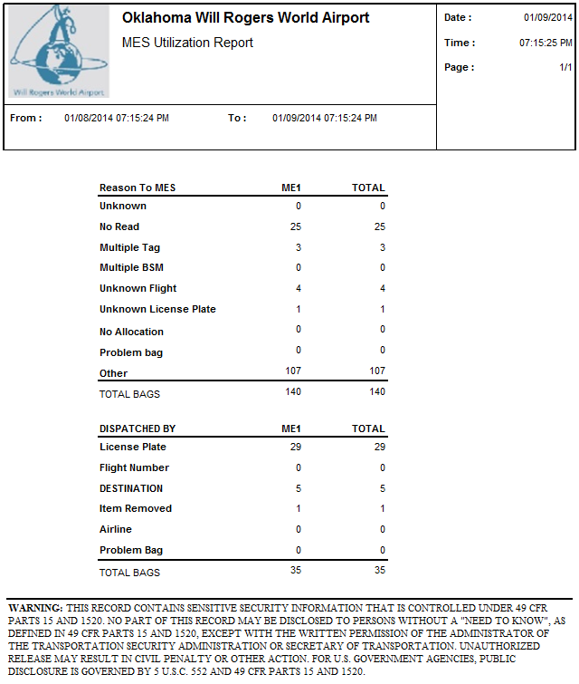

Figure 5‑7: MES Utilization Report

## Run-out Report

**General Information:**

|  |  |
| --- | --- |
| **Report Title** | Run-out Report |
| **Purpose** | Provides bag counts statistics for each departure and arrival make-up unit. |

**Report Boundaries:**

|  |  |  |
| --- | --- | --- |
| **No.** | **Parameter Name** | **Description** |
| 1 | From | The duration from which the data will be retrieved for the report. |
| 2 | To | The duration to which the data will be retrieved for the report. |
| 3 | Make-up unit | The make-up carousel to be included in the report. |

**Report Fields:**

|  |  |  |  |
| --- | --- | --- | --- |
| **No.** | **Fields Name** | **Data Type** | **Description** |
| 1 | SUBSYSTEM | Text | The runout subsystem. |
| 2 | Time | Time | The time when runout happened.  Format: hh:mm |
| 3 | BSM# | Text | The bag license plate. |
| 4 | EQUIPMENT ID | Text | The runout equipment ID. |
| 5 | REASON | Text | The runout reason. |

**Report Sample:**

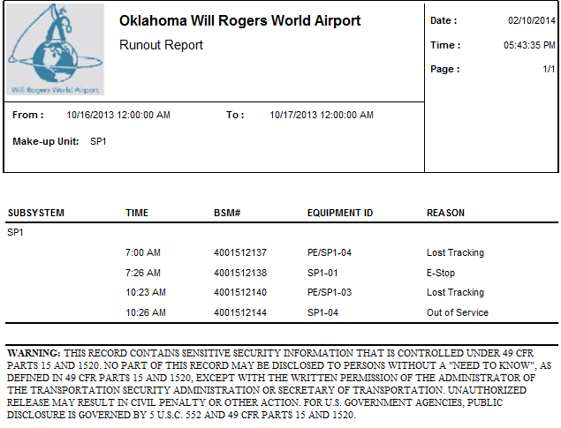

Figure 5‑8: Run-out Report

## EDS Report

**General Information:**

|  |  |
| --- | --- |
| **Report Title** | INDIVIDUAL EDS MACHINE STATUS REPORT |
| **Purpose** | Print out Individual EDS machine status. |

**Report Boundaries:**

|  |  |  |
| --- | --- | --- |
| **No.** | **Parameter Name** | **Description** |
| 1 | From | The duration from which the data will be retrieved for the report. |
| 2 | To | The duration to which the data will be retrieved for the report. |
| 3 | EDS ID | To specify EDS machine about which the status data will be shown |

**Report Fields (INDIVIDUAL EDS MACHINE STATUS REPORT):**

|  |  |  |  |
| --- | --- | --- | --- |
| **No.** | **Fields Name** | **Data Type** | **Description** |
| 1 | EDS NAME | Text | The identification of EDS machine. |
| 2 | SOFTWARE TYPE | Text | The software type of the selected EDS machine |
| 3 | SOFTWARE REVISION | Text | The software revision of the selected EDS machine |
|  | | | |
| 4 | EDS STATUS REGISTERS | - | - |
| 5 | Run position | Text | EDS machine run position. |
| 6 | Status | Text | The working status of the selected EDS. (Running/Online/Offline/Fault/Available/E-Stop/Warm-up). |
| 7 | PLC Scan Time | Text | The EDS machine PLC scan time. |
|  | | | |
| 8 | EDS AVAILABILITY AND COUNTS | - | - |
| 9 | E-Stop | Text | The total duration of E-stop. |
| 10 | Faults | Text | The total duration of Faults. |
| 11 | RTR High | Text | The total duration of RTR-High. |
| 12 | RTR Low | Text | The total duration of RTR-Low. |
| 13 | Jams | Numeric | The count of jams. |
|  | | | |
| 14 | Total Bags Screened | Numeric | The total count of bags screened. |
| 15 | Total Clear Bags | Numeric | The total count of bags cleared. |
| 16 | Total Alarmed Bags | Numeric | The total count of bags alarmed. |
| 17 | Total EDS Unkown Bags | Numeric | The total count of EDS unknown bags. |
| 18 | Total In Tracking Bags | Numeric | The total count of tracking bags. |
| 19 | Total BHS Unkown Bags | Numeric | The total count of BHS unknown bags. |
| 20 | Percentage BHS Unkown Bags (%) | Numeric | The percentage of BHS unknown bags. |
| 21 | EDS Decision Timeouts | Numeric | The total count of timeout. |
| 22 | EDS Flushes | Numeric | The total count of flushes |
| 23 | Average Level 2 Decision Time | Text | The average Level 2 decision time. |
| 24 | Average Bag Processing Time | Text | The average bag processing time. |

**Report Sample:**

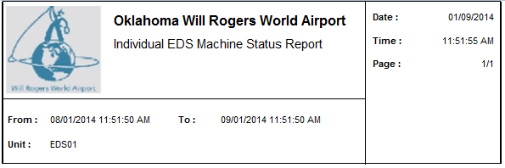

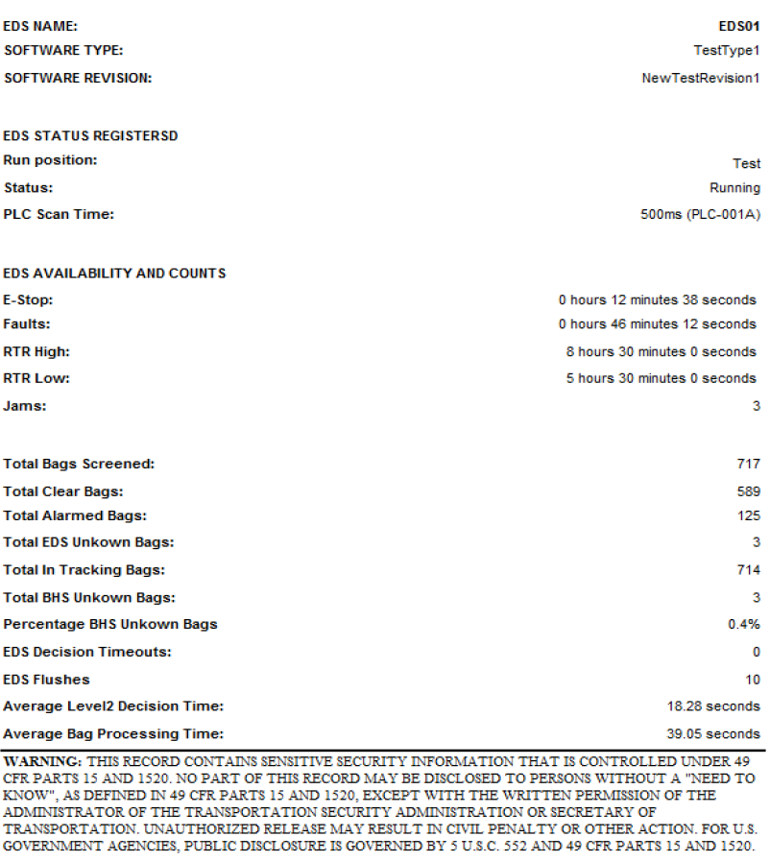

Figure 5‑9: HBS Process Report

## ATR Report

**General Information:**

|  |  |
| --- | --- |
| **Report Title** | ATR Report |
| **Purpose** | Provides number of faults, duration of faults, number of good reads, number of no read, number of multiple read, total reads and read rate for each ATR unit. |

**Report Boundaries:**

|  |  |  |
| --- | --- | --- |
| **No.** | **Parameter Name** | **Description** |
| 1 | From | The duration from which the data will be retrieved for the report. |
| 2 | To | The duration to which the data will be retrieved for the report. |
| 3 | ATR Unit | The ATR unit which the data will be retrieved for the report. |

**Report Fields 1 (statistics information for each head):**

|  |  |  |  |
| --- | --- | --- | --- |
| **No.** | **Fields Name** | **Data Type** | **Description** |
| 1 | ATR NUMBER | Text | The name of the ATR unit. |
| 2 | BAGS READ | Numeric | The count of bags read by each head. |
| 3 | % READ of TOTAL | Numeric | The percentage of bags read by each head. |

**Report Fields 2 (overall statistics information for the above ATR):**

|  |  |  |  |
| --- | --- | --- | --- |
| No. | Fields Name | Data Type | Description |
| 1 | BAGS SEEN | Numeric | The total count of bag seen by ATR. |
| 2 | BAGS READ | Numeric | The total good read bag count by ATR. |
| 3 | NO READS | Numeric | The total no read bag count by ATR. |
| 4 | VALID TAGS | Numeric | The total valid tags read by ATR. |
| 5 | CONFLICT TAGS | Numeric | The conflict tags read by ATR. |
| 6 | NO MATCHING BSM | Numeric | The tags without matching BSM information. |
| 7 | Read Rate (%) | Numeric | The ATR read rate. |

**Report Sample:**

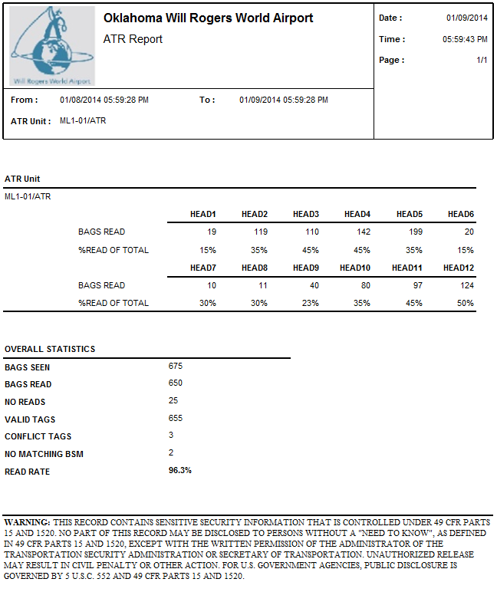

Figure 5‑10: ATR and BMA Report

## Day End Report

**General Information:**

|  |  |
| --- | --- |
| **Report Title** | Day End Report |
| **Purpose** | Provides throughputs, ATR scanner statistics, manual encoding statistics and sort outputs. |

**Report Boundaries:**

|  |  |  |
| --- | --- | --- |
| **No.** | **Parameter Name** | **Description** |
| 1 | From | The duration from which the data will be retrieved for the report. |
| 2 | To | The duration to which the data will be retrieved for the report. |

**Report Fields:**

|  |  |  |  |
| --- | --- | --- | --- |
| **No.** | **Fields Name** | **Data Type** | **Description** |
| **1** | **THROUGHPUT** | **-** | **-** |
| 1.1 | INPUT | Text | The location of the input load point. |
| 1.2 | BAGS | Numeric | The total bag counts loaded in input load point. |
| **2** | **ATR LASER STATS** | **-** | **-** |
| 2.1 | ARRAY | Text | The name or id of ATR array. |
| 2.2 | BAGS READ | Numeric | The total count of bag read by each ATR. |
| 2.3 | LATE BAGS | Numeric | The total count of late bags |
| 2.4 | BAGS SEEN | Numeric | The total count of bag seen by each ATR. |
| 2.5 | READ RATE% | Numeric | The percentage of bag read out of bags seen by each ATR. |
| **3** | **BMA STATS** | **-** | **-** |
| 3.1 | ARRAY | Text | The name of BDD array |
| 3.2 | NORMAL BAG | Numeric | The total count of bags dimensioned to be normal. |
| 3.3 | BAGS DIMENSIONED | Numeric | The total count of bag dimensioned by each BDD array. |
| 3.4 | DIMENSION RATE% | Numeric | The percentage of bag read out of bags dimensioned by each BDD. |
| **4** | **MANUAL ENCODE STATS** | **-** | **-** |
| 4.1 | STATION | Text | The location for MES. |
| 4.2 | BAGS | Numeric | The total count of bags scanned by each MES. |
| **5** | **EDS MACHINE SECURITY SYSTEM STATS** | **-** | **-** |
| 5.1 | MACHINE | Text | The name of EDS machine |
| 5.2 | BAGS | Numeric | The total count of bags checked by EDS machine |
| 5.3 | BAGS CLEARED | Numeric | The count of bags cleared by EDS. |
| 5.4 | BAGS ALARMED | Numeric | The count of bags alarmed by EDS. |
| 5.5 | PERCENTAGE CLEARED | Numeric | The percentage of bags cleared out of total bags checked by EDS |
| **6** | **OUTPUTS** | **-** | **-** |
| 6.1 | CHUTE/PIER/MAKE-UP UNIT | Text | The location for the output location for make-up carousel. |
| 6.2 | BAGS | Numeric | The total bag count for the output location for make-up carousel. |
| **7** | **TRACKING** | **-** | **-** |
| 7.1 | LINE | Text | The identification of the equipment location. |
| 7.2 | NUMBER OF BAGS | Numeric | The total number of bag count (successful tracked bags and lost tracked bags) on each location. |
| 7.3 | NUMBER LOST TRACKING | Numeric | The number of bag count for unsuccessful or lost tracked baggage. |
| 7.4 | TRACKING PERCENTAGE (MIN 99%) | Numeric | The tracking successful percentage |

**\*Please not that this report will be configured on the Reporting Subscription to automatically generate and print daily reports.**

**Report Sample:**

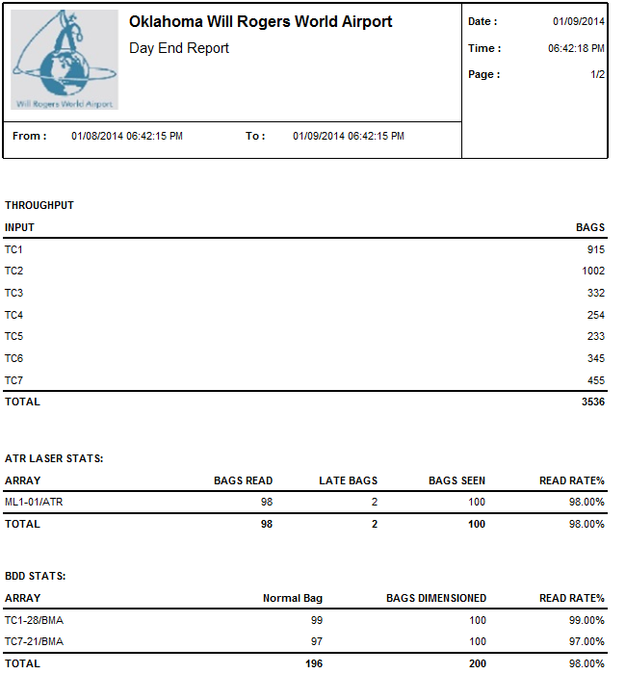

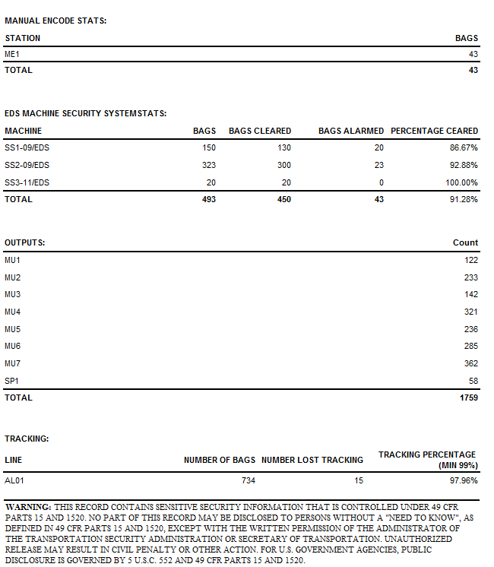

Figure 5‑11: Day End Report

## Active Flight Report

**General Information:**

|  |  |
| --- | --- |
| **Report Title** | Permanent Flight Report |
| **Purpose** | This report shows the currently active flight schedule that is updated every day by coping flights from all appropriate permanent flight schedules, and then updated by FIS. |

**Report Boundaries:**

|  |  |  |
| --- | --- | --- |
| **No.** | **Parameter Name** | **Description** |
| 1 | From | The duration from which the data will be retrieved for the report. |
| 2 | To | The duration to which the data will be retrieved for the report. |
| 3 | Airline | The Airline to be included in the report. This parameter can have multiple values. |
| 4 | Flight Number | The Flight Number to be included in the report. This parameter can have multiple values. |

**Report Fields:**

|  |  |  |  |
| --- | --- | --- | --- |
| **No.** | **Fields Name** | **Data Type** | **Description** |
| 1 | Days | Text | The active flight schedule is grouped by “yesterday”, “today” and “tomorrow”. |
| 1 | Airline | Text | The airline for which the flight belong to. |
| 2 | Flight | Text | The flight number of the data. |
| 3 | Weekdays | Numeric | The weekdays of each flight |
| 4 | STD | Text | The schedule time of departure for each flight |
| 5 | Resources | Numeric | The allocated Make-up carousel |

**Report Sample:**

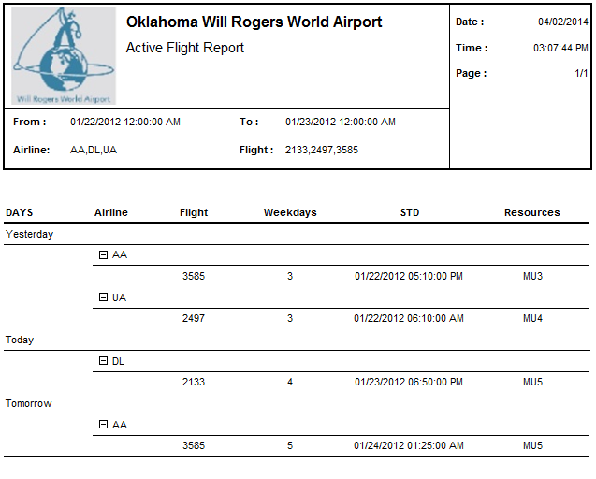

Figure 5‑12: Sort Area Assignment Report

## Permanent Flight Report

**General Information:**

|  |  |
| --- | --- |
| **Report Title** | Permanent Flight Report |
| **Purpose** | This report shows the flight schedule that is pre-configured, prepared for specific day for active flight schedule, and currently being used to determine the sort assignments for flights. |

**Report Boundaries:**

|  |  |  |
| --- | --- | --- |
| **No.** | **Parameter Name** | **Description** |
| 1 | From | The duration from which the data will be retrieved for the report. |
| 2 | To | The duration to which the data will be retrieved for the report. |
| 3 | Airline | The Airline to be included in the report. This parameter can have multiple values. |
| 4 | Flight Number | The Flight Number to be included in the report. This parameter can have multiple values. |

**Report Fields:**

|  |  |  |  |
| --- | --- | --- | --- |
| **No.** | **Fields Name** | **Data Type** | **Description** |
| 1 | Airline | Text | The airline for which the flight belong to. |
| 2 | Flight | Text | The flight number of the data. |
| 3 | Weekdays | Numeric | The weekdays of each flight |
| 4 | STO | Text | The schedule time of operation for each flight |
| 5 | Resources | Numeric | The allocated Make-up carousel |

**Report Sample:**

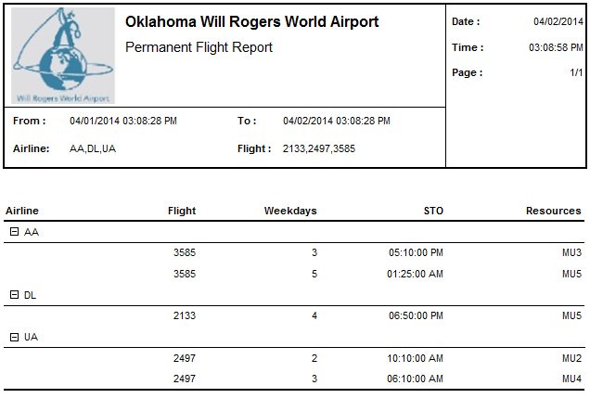

Figure 5‑13: Sort Area Assignment Report

## Sort Area Assignment Report

**General Information:**

|  |  |
| --- | --- |
| **Report Title** | Sort Area Assignment Report |
| **Purpose** | Printout of Physical Make-up is assigned or reassigned to which Make-up carousel. |

**Report Boundaries:**

|  |  |  |
| --- | --- | --- |
| **No.** | **Parameter Name** | **Description** |
| 1 | From | The duration from which the data will be retrieved for the report. |
| 2 | To | The duration to which the data will be retrieved for the report. |

**Report Fields:**

|  |  |  |  |
| --- | --- | --- | --- |
| **No.** | **Fields Name** | **Data Type** | **Description** |
| 1 | PHYSICAL MAKE-UP | Text | The name of physical make-up device |
| 2 | ASSIGNED TO | Text | The name of make-up device to which the physical make-up device is assigned.  Labeled if it is reassigned |

**Report Sample:**

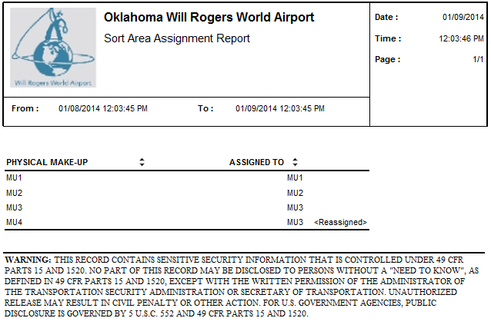

Figure 5‑14: Sort Area Assignment Report

## BSM Report

**General Information:**

|  |  |
| --- | --- |
| **Report Title** | BSM Report |
| **Purpose** | Printout of all tag numbers during the operational period. |

**Report Boundaries:**

|  |  |  |
| --- | --- | --- |
| **No.** | **Parameter Name** | **Description** |
| 1 | From | The duration from which the data will be retrieved for the report. |
| 2 | To | The duration to which the data will be retrieved for the report. |
| 3 | Airline | The Airline to be included in the report. This parameter can have multiple values. |
| 4 | Flight Number | The Flight Number to be included in the report. This parameter can have multiple values. |

**Report Fields:**

|  |  |  |  |
| --- | --- | --- | --- |
| **No.** | **Fields Name** | **Data Type** | **Description** |
| 1 | Tag ID | Text | The Tag ID of the baggage. |
| 2 | PAX Name | Text | The passenger name. |
| 3 | Airline | Text | The airline for which the BSM belongs to. |
| 4 | Flight | Text | The flight number of the BSM. |
| 5 | Time Seen | Text | The time when the bag was read. |
| 6 | READ | Text | The location of ATR where the bag was read before arriving to a pier destination or MES. |
| 7 | BAG TYPE | Text | The bag type (outbound, transfer…..) |
| 8 | BSM REC’D | Text | Indicating the time when BSM was received at the BHS from the Host. |

**\*Please note that only baggage which has BSM in BHS system will be shown in this report.**

**Report Sample:**

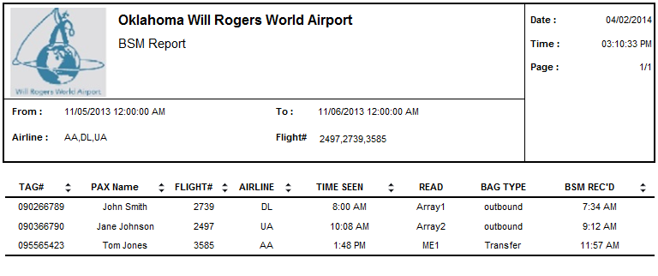

Figure 5‑15: BSM Report

## Computer and PLC Status Report

**General Information:**

|  |  |
| --- | --- |
| **Report Title** | Computer and PLC Status Report |
| **Purpose** | Provides computer and PLC online/offline and current status. |

**Report Boundaries:**

None.

**Report Fields:**

|  |  |  |  |
| --- | --- | --- | --- |
| **No.** | **Fields Name** | **Data Type** | **Description** |
| **1** | **Computer Status** |  |  |
| 1.1 | Computer ID | Text | The identification of computer and workstation. |
| 1.2 | Online/Offline Status | Text | The Online/Offline status of the equipment. |
| 1.3 | Status | Text | The current status of the equipment. |
| **2** | **Sort Controller** |  |  |
| 2.1 | Sort Controller ID | Text | The identification of Sort Controller. |
| 2.2 | Online/Offline Status | Text | The Online/Offline status of the equipment. |
| 2.3 | Status | Text | The current status of the equipment. |
| **3** | **PLC BANK** |  |  |
| 3.1 | PLC Bank ID | Text | The identification of PLC. |
| 3.2 | Online/Offline Status | Text | The Online/Offline status of the equipment. |
| 3.3 | Status | Text | The current status of the equipment. |
| **4** | **UPS Status** |  |  |
| 4.1 | UPS ID |  | The identification of UPS |
| 4.2 | UPS Charge Percentage(%) | Numeric | The remaining power of the UPS. |
| 4.3 | Status | Text | The current status of the UPS. |
| 4.4 | Runtime Remaining | Time | If battery powered, the remaining run time. |

**Report Sample:**

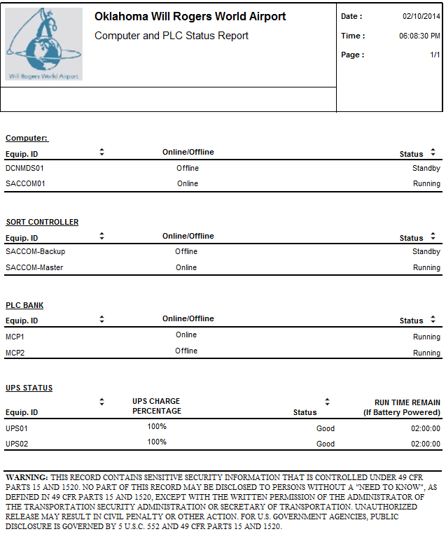

Figure 5‑16: Computer and PLC Status Report

## Individual PLC Status Report

**General Information:**

|  |  |
| --- | --- |
| **Report Title** | Individual PLC Status Report |
| **Purpose** | Provides Individual PLC status. |

**Report Boundaries:**

|  |  |  |
| --- | --- | --- |
| **No.** | **Parameter Name** | **Description** |
| 1 | PLC ID | The PLC name from which the data will be retrieved for the report. |

**Report Fields:**

|  |  |  |  |
| --- | --- | --- | --- |
| **No.** | **Fields Name** | **Data Type** | **Description** |
| 1 | Report Type |  |  |
| 2 | PLC Name | Text | The name or identification of the selected PLC. |
| 3 | Software Type | Text | The software type of the selected PLC. |
| 4 | Software Revision | Text | The Software revision of the selected PLC. |
|  | | | |
| 5 | PLC Status Registers | - | - |
| 6 | Key position | Text | Run/Program/Remote. |
| 7 | Status | Text | Running/Online/Offline/Fault/Available. |
|  | | | |
| 8 | LED Status | - | - |
| 9 | Processor | Text | The LED Status of PLC processor. |
| 10 | Force | Text | The LED Status of PLC force. |
| 11 | Communication | Text | The LED Status of PLC communication. |
| 12 | Battery Power | Text | The LED Status of PLC battery power. |
|  | | | |
| 13 | Memory Size | Numeric | The memory size of the selected PLC. |
| 14 | Memory Used | Numeric | The memory already used. |
| 15 | Memory Compiled | Numeric | The memory compiled. |
| 16 | Rung Count | Numeric | The rung consumed. |
| 17 | Scan Time | Time | The program scan time. |
|  | | | |
| 18 | Fault Error Code | - | - |
| 19 | Processor Error | Numeric | The count of processor error for the selected PLC. |
| 20 | Network Error | Numeric | The count of network error for the selected PLC. |

**Report Sample:**

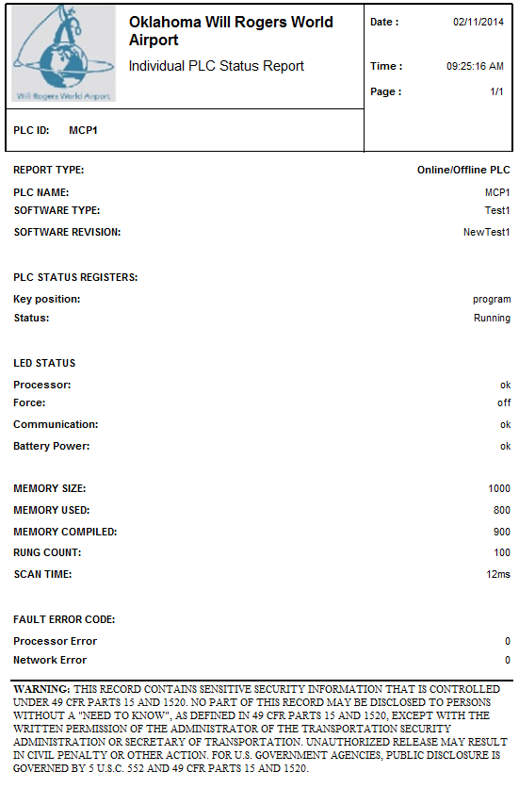

Figure 5‑17: Individual PLC Status Report

## Bags Data Reports

**General Information:**

|  |  |
| --- | --- |
| **Report Title** | Bag Data Report |
| **Purpose** | Provides information of the bags. |

**Report Boundaries:**

|  |  |  |
| --- | --- | --- |
| **No.** | **Parameter Name** | **Description** |
| 1 | From | The duration from which the data will be retrieved for the report. |
| 2 | To | The duration to which the data will be retrieved for the report. |

**Report Fields:**

|  |  |  |  |
| --- | --- | --- | --- |
| **No.** | **Fields Name** | **Data Type** | **Description** |
| 1 | BHS Tracking ID | Text | The bag GID. |
| 2 | Bag Type | Text | The bag type (OOG or in-spec). |
| 3 | Time Stamp BMA | Text | Time Stamped when entering into BMA |
| 4 | Time Stamp Entering  (EDS or OOG) | Text | Time Stamped when entering into the EDS machine or time Stamped when OOG bags are identified. |
| 5 | LeveL1 Status | Text | Level 1 Screening Status. |
| 6 | Level 1 Time Stamp | Text | Time Stamped at Level 1 Screening Decision. |
| 7 | Level 2 Status | Text | Level 2 Screening Status. |
| 8 | Level 2 Time Stamp | Text | Time Stamped at Level 2 Screening Decision. Note: Not all EDS machines have the capability to time stamp at both Level 1 and decisions - Confirm with EDS OEM. |
| 9 | CBRA Time Delivered | Text | Time Stamped when delivered to CBRA Unload Conveyors. |
| 10 | CBRA Time Removed | Text | Time Stamped when removed from CBRA Unload Conveyors. |

**Report Sample:**

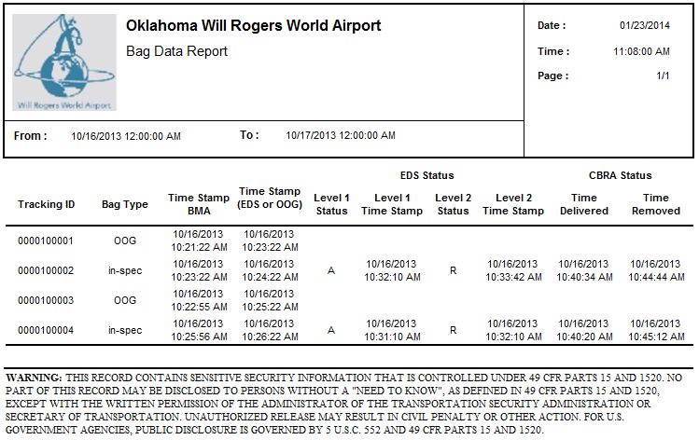

Figure 5‑18: Bags Data Report

## EDS Statistics Reports

**General Information:**

|  |  |
| --- | --- |
| **Report Title** | EDS Statistics Report |
| **Purpose** | Printout of EDS statistics information for each EDS machine |

**Report Boundaries:**

|  |  |  |
| --- | --- | --- |
| **No.** | **Parameter Name** | **Description** |
| 1 | From | The duration from which the data will be retrieved for the report. |
| 2 | To | The duration to which the data will be retrieved for the report. |

**Report Fields:**

|  |  |  |  |
| --- | --- | --- | --- |
| **No.** | **Fields Name** | **Data Type** | **Description** |
| 1 | EDS ID | Text | The identification of EDS machine. |
| 2 | Operation Start Time | Text | Start time of operation. |
| 3 | Operation End Time | Text | End time of operation. |
| 4 | Operation Duration | Text | EDS Machine operational duration. |
| 5 | Bags Alarmed | Numeric | Count of Bags Alarmed by Specific EDS Machine. |
| 6 | Bags Cleared | Numeric | Count of Bags Cleared by Specific EDS Machine. |
| 7 | EDS Machine Faults | Numeric | The description of EDS Machine faults (if it is known). |
| 8 | Fault Start Time | Text | Start time of fault. |
| 9 | Fault End Time | Text | End time of fault. |

**Report Sample:**

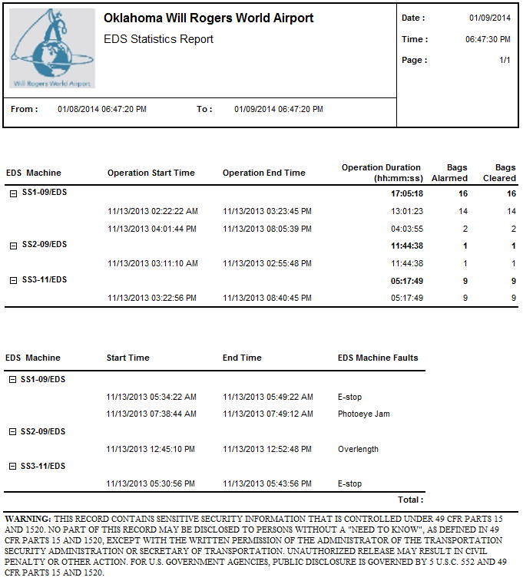

Figure 5‑19: EDS statistics Report

## Critical Tracking PEC Report

**General Information:**

|  |  |
| --- | --- |
| **Report Title** | Critical Tracking PEC Report |
| **Purpose** | Provides critical tracking information about each bag on some important subsystems. Immediately upstream and downstream of each EDS, prior to and after each tracked divert point, and at the last tracked photoeye entering the CBRA. |

**Report Boundaries:**

|  |  |  |
| --- | --- | --- |
| **No.** | **Parameter Name** | **Description** |
| 1 | From | The duration from which the data will be retrieved for the report. |
| 2 | To | The duration to which the data will be retrieved for the report. |

**Report Fields 1:**

|  |  |  |  |
| --- | --- | --- | --- |
| **No.** | **Fields Name** | **Data Type** | **Description** |
| 1 | Screening Status | Text | The screening type of EDS machine |
| 2 | Number of Bags | Numeric | The IATA License Plate |

**Report Fields 2:**

|  |  |  |  |
| --- | --- | --- | --- |
| **No.** | **Fields Name** | **Data Type** | **Description** |
| 1 | IATA/Pseudo# | Text | The IATA License Plate or Pseudo number of bags |
| 2 | EDS ID | Text | The identification of EDS machine |
| 3 | Action | Text | The action made by subsystem for each bag |
| 4 | Time | Date Time | The date time of each action |
| 5 | EDS Status | Text | The screening result of EDS for each bag |

**Report Sample:**

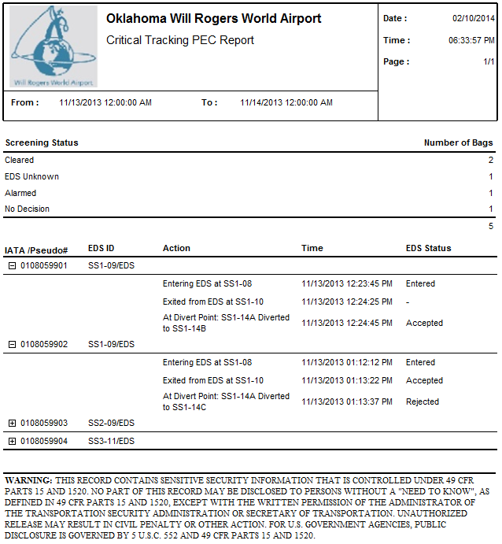

Figure 5‑20: Critical Tracking PEC Report

## Tracking Photocell Report

**General Information:**

|  |  |
| --- | --- |
| **Report Title** | Tracking Photocell Report |
| **Purpose** | Provides number of occurrences of problems with each tracking photocells. |

**Report Boundaries:**

|  |  |  |
| --- | --- | --- |
| **No.** | **Parameter Name** | **Description** |
| 1 | From | The duration from which the data will be retrieved for the report. |
| 2 | To | The duration to which the data will be retrieved for the report. |
| 3 | Subsystem | The selection of Subsystem which wants to display the details. This parameter can have multiple values. |

**Report Fields:**

|  |  |  |  |
| --- | --- | --- | --- |
| **No.** | **Fields Name** | **Data Type** | **Description** |
| 1 | Photocell ID | Text | Photocell ID. |
| 2 | Bags Seen | Numeric | Total number of bags for photocell. |
| 3 | Missing Bags | Numeric | Number of bags missing at photocell. |
| 4 | Unknown Bags | Numeric | Number of unknown bags at photocell. |
| 5 | Bag Jams | Numeric | Number of bag jams at each photocell. |
| 6 | Missing Bags Jams | Numeric | Number of missing bag jams at photocell. |

**Report Sample:**

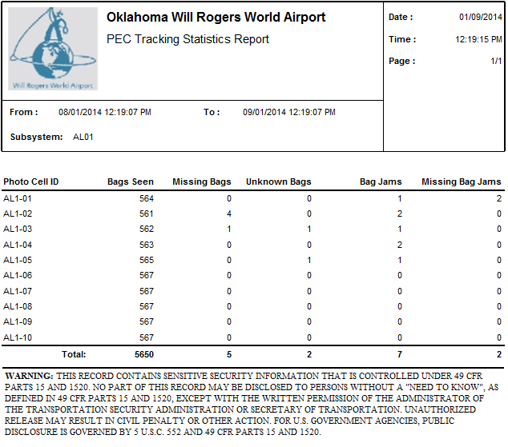

Figure 5‑21: Tracking Photocell Report

## Tracking Statistics Report

**General Information:**

|  |  |
| --- | --- |
| **Report Title** | Tracking Photocell Report |
| **Purpose** | Provides number of occurrences of problems with each tracking photocells. |

**Report Boundaries:**

|  |  |  |
| --- | --- | --- |
| **No.** | **Parameter Name** | **Description** |
| 1 | From | The duration from which the data will be retrieved for the report. |
| 2 | To | The duration to which the data will be retrieved for the report. |
| 3 | Subsystem | The selection of Subsystem which wants to display the details. This parameter can have multiple values. |

**Report Fields:**

|  |  |  |  |
| --- | --- | --- | --- |
| **No.** | **Fields Name** | **Data Type** | **Description** |
| 1 | Subsystem | Text | The subsystem for Bags Tracking statistics |
| 2 | Total Bags | Numeric | Total number of bags for photocell seen. |
| 3 | Lost Bags | Numeric | Number of bags lost at photocell. |
| 4 | Lost Rate | Numeric | The percentage of lost bags out of total bags |

**Report Sample:**

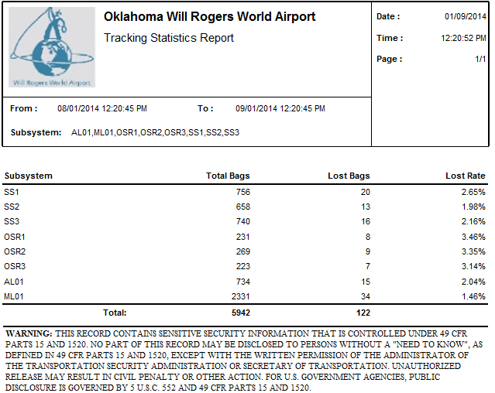

Figure 5‑22: Tracking Statistics Report

## Baggage Measuring Statistics Report

**General Information:**

|  |  |
| --- | --- |
| **Report Title** | Baggage Measuring Statistics Report |
| **Purpose** | Provides information for the Baggage Dimension Device. |

**Report Boundaries:**

|  |  |  |
| --- | --- | --- |
| **No.** | **Parameter Name** | **Description** |
| 1 | From | The duration from which the data will be retrieved for the report. |
| 2 | To | The duration to which the data will be retrieved for the report. |

**Report Fields:**

|  |  |  |  |
| --- | --- | --- | --- |
| **No.** | **Fields Name** | **Data Type** | **Description** |
| **1** | **BDD Statistics** | **-** | **-** |
| 1.1 | BDD ID | Text | The Baggage Dimension Device identification. |
| 1.2 | Out of Gauge | Numeric | The total count of out of gauge bag. |
| 1.3 | Normal | Numeric | The total count of normal size bag. |
| 1.4 | Not Dimensioned | Numeric | The total count of bag not dimensioned as PLC did not received any dimension data for the baggage. |
| 1.5 | Count | Numeric | The total counts of bags passed through BDD. |
| **2** | **BDD Fault** | **-** | **-** |
| 2.1 | BDD ID | Text | The Baggage Dimension Device identification. |
| 2.2 | Start Time | Text | The start time for the BDD fault occurred. |
| 2.3 | End Time | Text | The end time for the BDD fault occurred. If the fault is still not recovered, this field will be empty. |
| 2.4 | Duration (HH:mm:ss) | Text | The duration of the BDD fault occurrence specified in HH:mm:ss format. If the fault is still not recovered, this field will be empty.  *Note: HH = hours (24 hours format), mm = minutes, ss = seconds* |
| 2.5 | Count | Numeric | The total counts of BDD fault occurred. |

**Report Sample:**

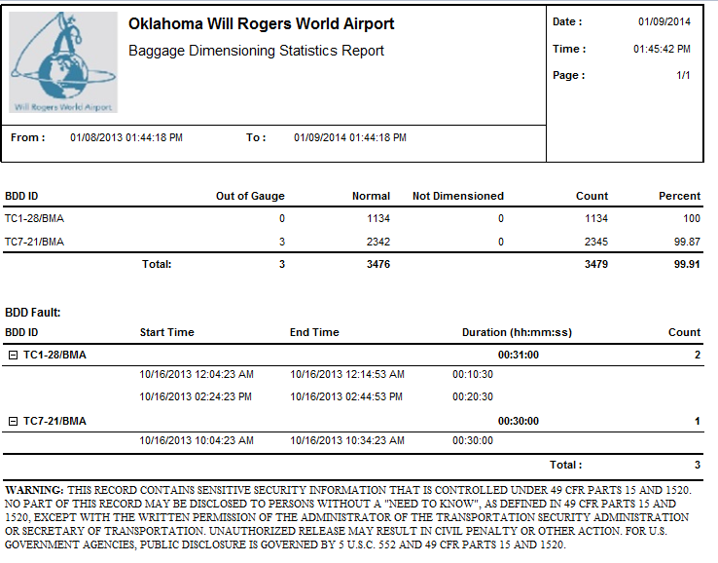

Figure 5‑23: Baggage Measuring Statistics Report

## OSR Statistics Report

**General Information:**

|  |  |
| --- | --- |
| **Report Title** | OSR Statistics Report |
| **Purpose** | Provides information for the OSR process. |

**Report Boundaries:**

|  |  |  |
| --- | --- | --- |
| **No.** | **Parameter Name** | **Description** |
| 1 | From | The duration from which the data will be retrieved for the report. |
| 2 | To | The duration to which the data will be retrieved for the report. |
| 3 | Subsystem | The selection of Subsystem which wants to display the details. This parameter can have multiple values. |

**Report Fields:**

|  |  |  |  |
| --- | --- | --- | --- |
| **No.** | **Fields Name** | **Data Type** | **Description** |
| 1 | OSR ID | Text | The OSR identification. |
| 2 | Total Bags | Numeric | The total count of bags through OSR. |
| 3 | Bags by EDS | Numeric | The total count of bags through OSR by EDS. |
| 4 | Bags cleared | Numeric | The total count of bags cleared by OSR. |
| 5 | Average Time | Numeric | The Average Time to clear bag by OSR. |

**Report Sample:**

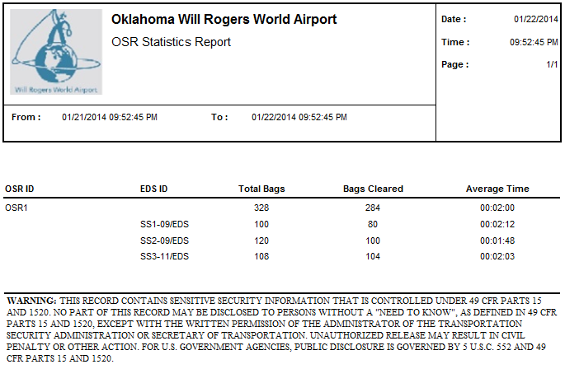

Figure 5‑24: OSR Statistics Report

## CBRA Area statistics Report

**General Information:**

|  |  |
| --- | --- |
| **Report Title** | CBRA Statistics Report |
| **Purpose** | Provides information for the CBRA Area. |

**Report Boundaries:**

|  |  |  |
| --- | --- | --- |
| **No.** | **Parameter Name** | **Description** |
| 1 | From | The duration from which the data will be retrieved for the report. |
| 2 | To | The duration to which the data will be retrieved for the report. |

**Report Fields:**

|  |  |  |  |
| --- | --- | --- | --- |
| **No.** | **Fields Name** | **Data Type** | **Description** |
| 1 | CBRA ID | Text | The identification of CBRA |
| 2 | ETD Station | Text | The identification of ETD station |
| 3 | Bags Received | Numeric | Total Number of Bags Received by each ETD. |
| 4 | Bags Cleared | Numeric | Total Number of Bags Cleared by CBRA. |
| 5 | Percentage | Numeric | The percentage of bags cleared out of bags received by CBRA |

**Report Sample:**

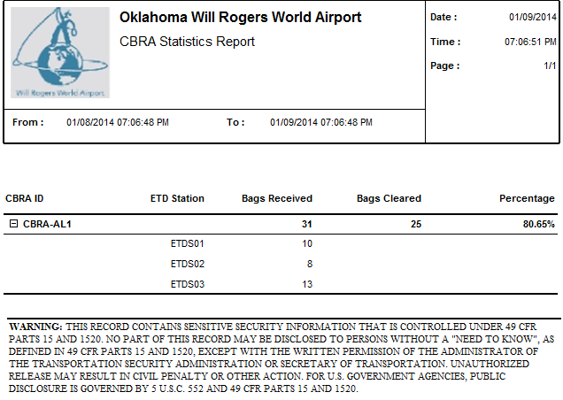

Figure 5‑25: CBRA Area statistics Report

## Bag Tag Not Found Report

**General Information:**

|  |  |
| --- | --- |
| **Report Title** | Bag Tag Not Found Report |
| **Purpose** | Provides all the bag tags read with no destination details. |

**Report Boundaries:**

|  |  |  |
| --- | --- | --- |
| **No.** | **Parameter Name** | **Description** |
| 1 | From | The duration from which the data will be retrieved for the report. |
| 2 | To | The duration to which the data will be retrieved for the report. |

**Report Fields:**

|  |  |  |  |
| --- | --- | --- | --- |
| **No.** | **Fields Name** | **Data Type** | **Description** |
| 1 | CARRIER ID | Text | The carrier ID. |
| 2 | TAG NUMBER  NOT FOUND | Text | The tag number of the baggage without destination. |
| 3 | TIME SEEN | Text | The timestamp when the baggage is scanned. (hh:mm) |
| 4 | LOCATION SEEN | Text | The device where the bag tag is scanned. |
| 5 | PAX NAME | Text | The passenger name. |
| 6 | FLT# | Text | The airline and flight number of the baggage belongs to. |

**Report Sample:**

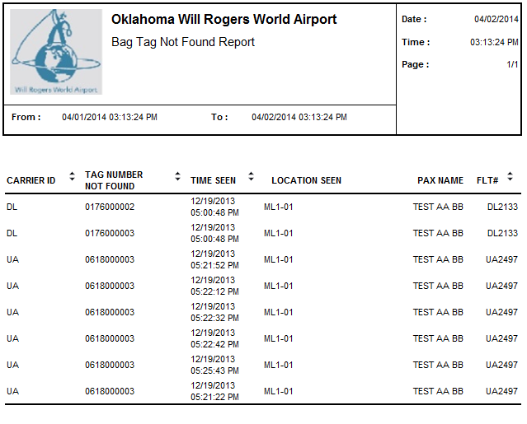

Figure 5‑26: Bag Tag Not Found Report Sample